DRAFTING PRACTICES - DP232270

ALLOCATION OF MARKS
S.No | Description | Allotted Marks | Awarded Marks
A | 25 One-mark Questions (25 × 1 = 25 marks) | 25
B | (i). Drawing & dimensioning using CAD (1 × 25 = 25 marks) | 25
 | (ii). Department specific drawing using CAD (1 × 25 = 25 marks) | 45
C | Viva-voce | 05
 | TOTAL | 100

PART-B (COMPUTER AIDED DRAFTING USING CAD SOFTWARE)
(i). Draw the orthographic views of the given component using CAD (1 × 25 = 25 marks)
(COMMON FOR ALL BRANCHES )

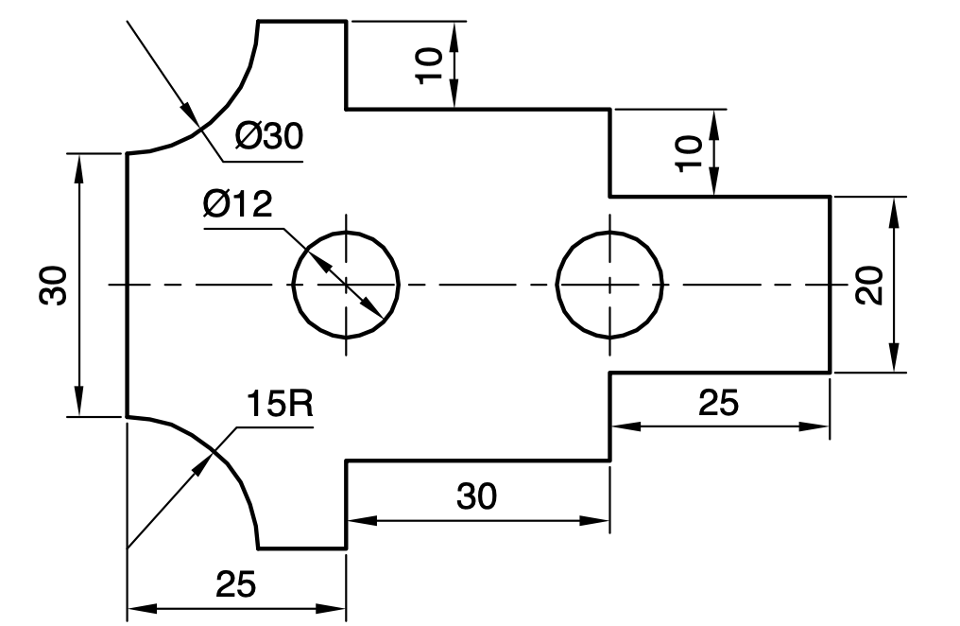
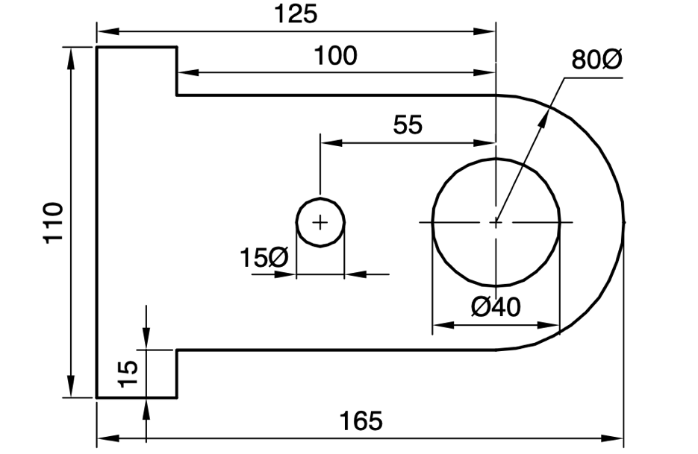

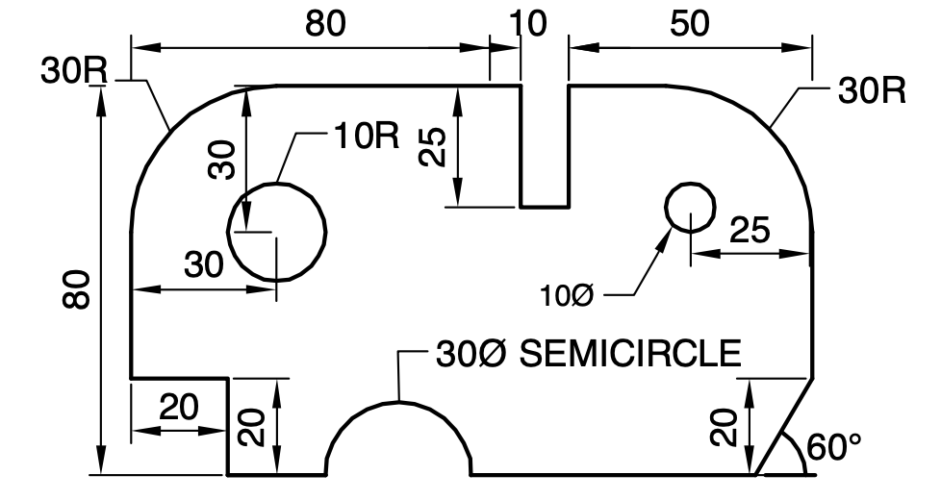

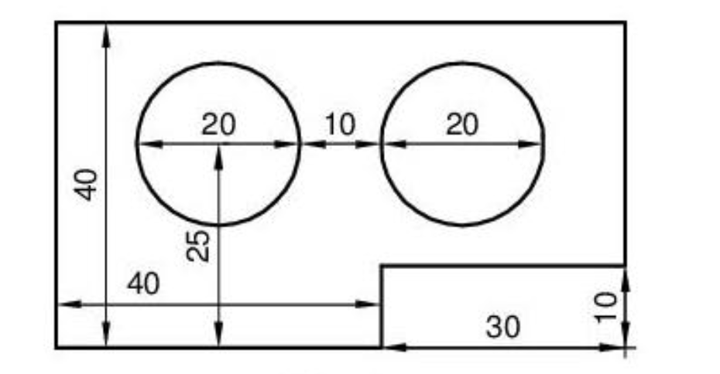

(ii). Draw the orthographic views of the given component using CAD – (1 × 25 = 25 marks) Mechanical
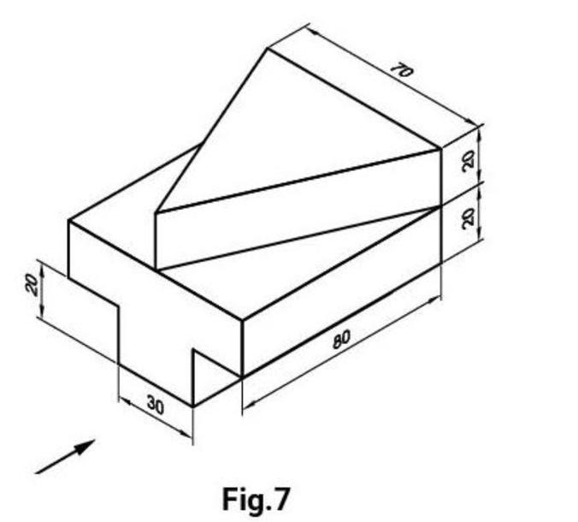
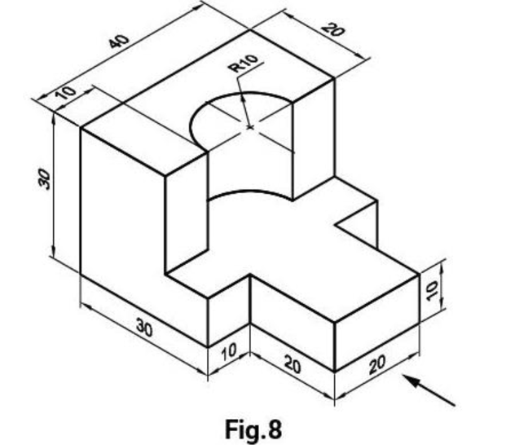
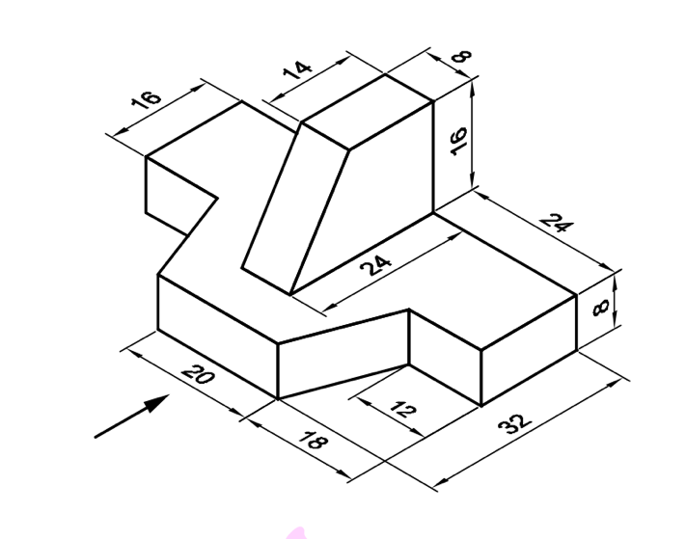
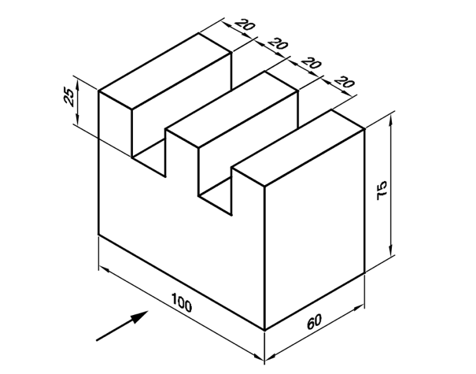

(ii). Draw the given civil engineering drawing using CAD – Civil (1 × 25 = 25 marks)
(a) Cross sectional view of L-section, T-section, Channel and I-Section
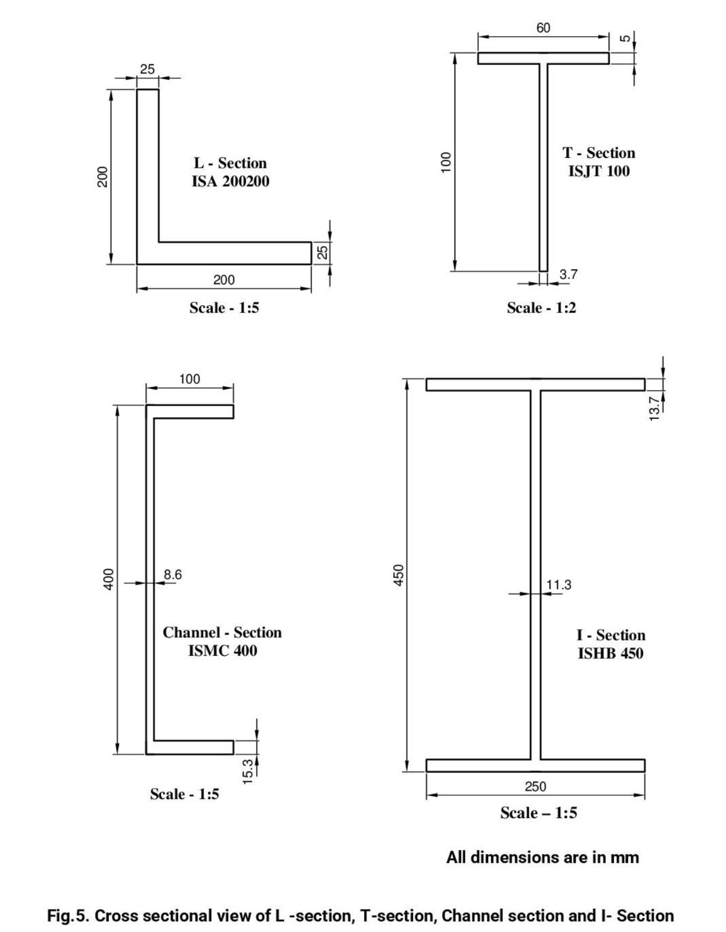

(b) Plan, Elevation and Sectional view of a Single storey, Single room building consisting of RCC Flat Roof, Masonry walls, Lintel cum Sunshade, Door and windows of standard size.
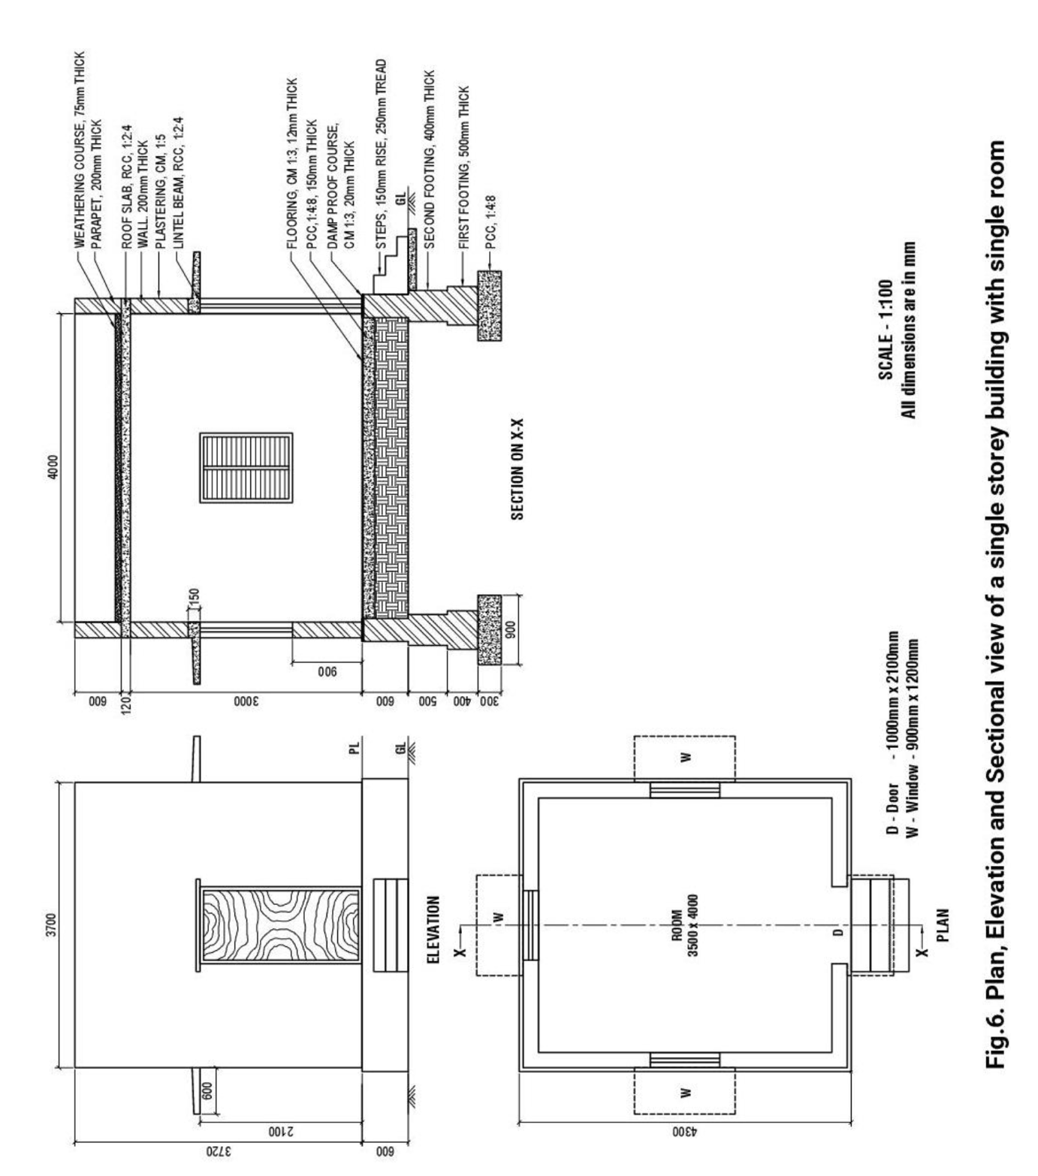

(c) Floor plan of a 2BHK residential building.
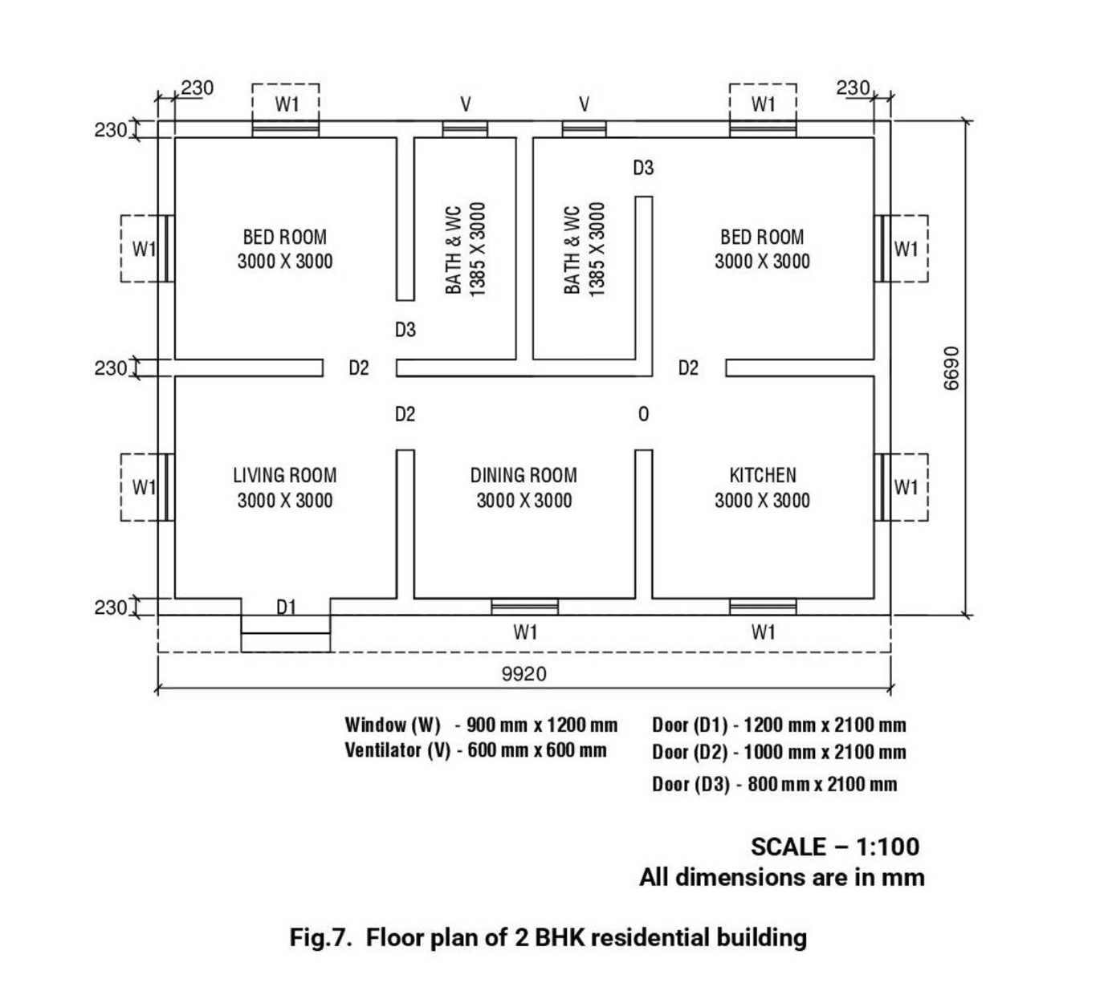

(d) Plan and Sectional Elevation of a RCC Column with square isolated footings.
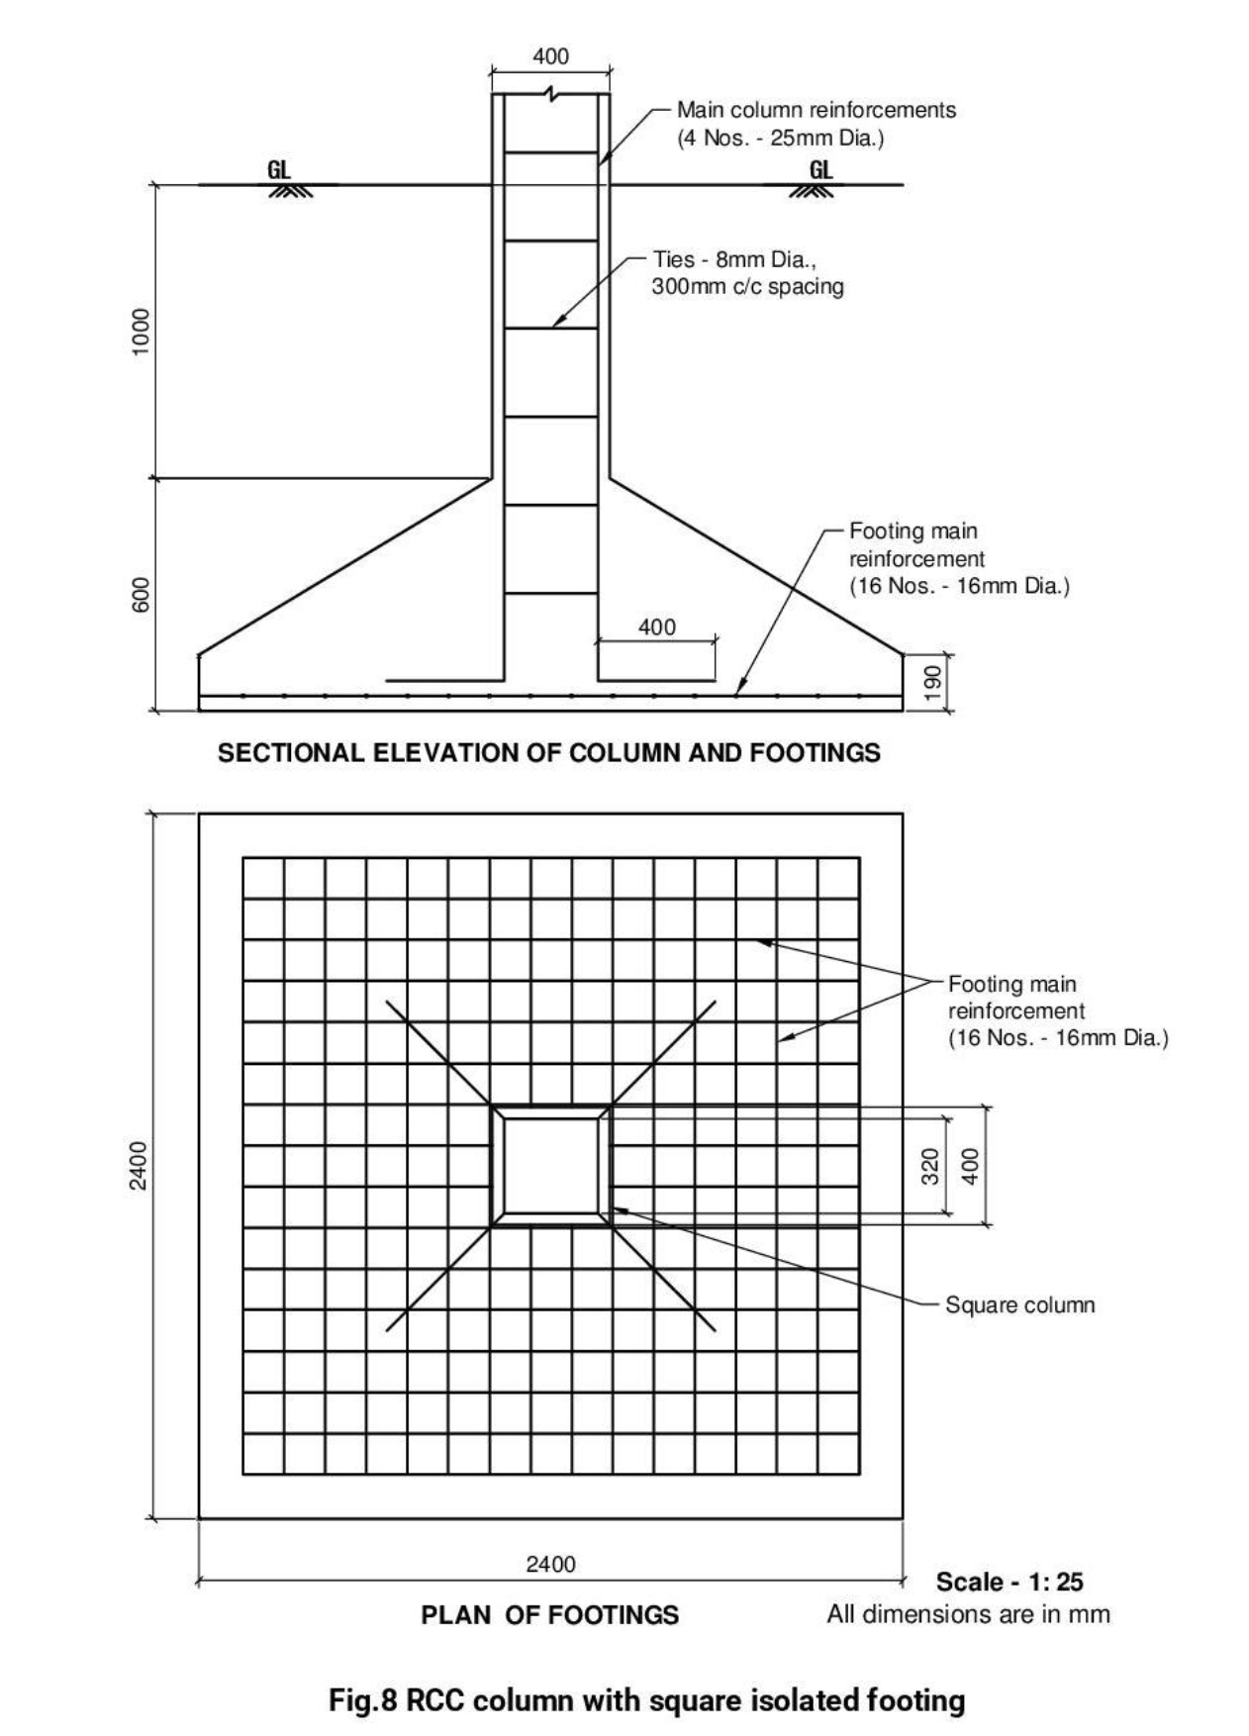

(ii). Draw the given electric circuit diagram using CAD – EEE (1 × 25 = 25 marks)
- Stair-case wiring electric circuit
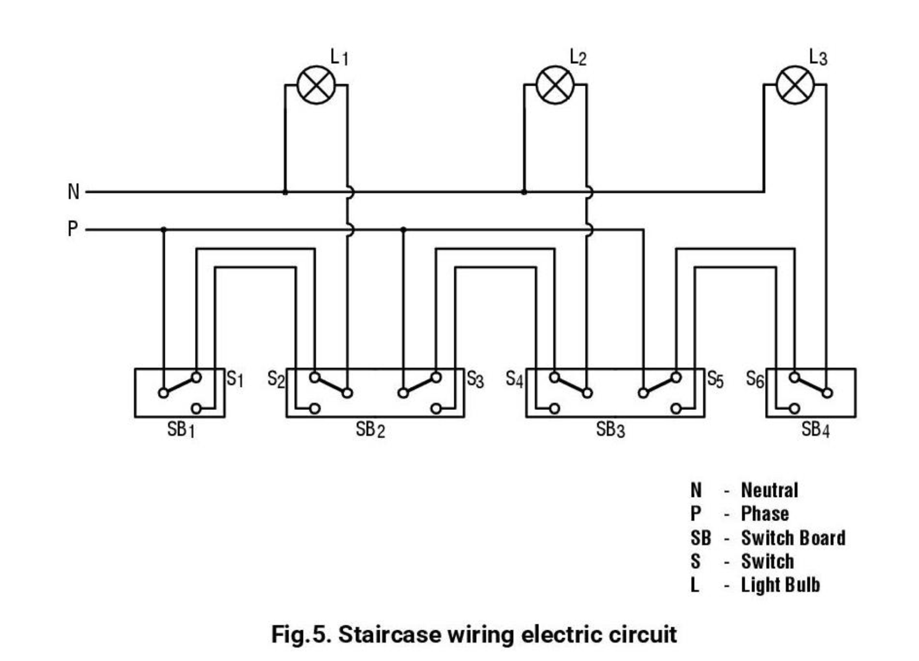

(b) Control and main circuit of automatic star delta starter (c) Control circuit for jogging in cage induction motor
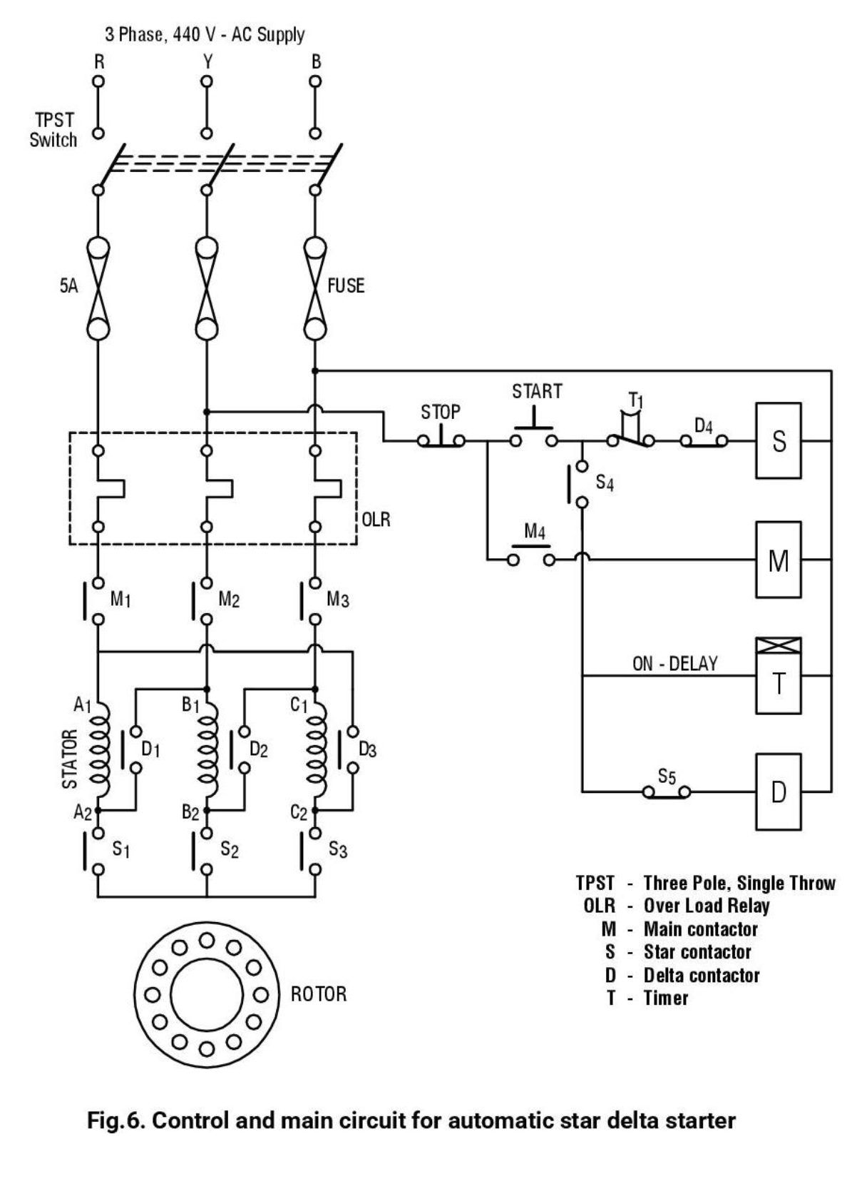

(d) Single phase wiring circuit
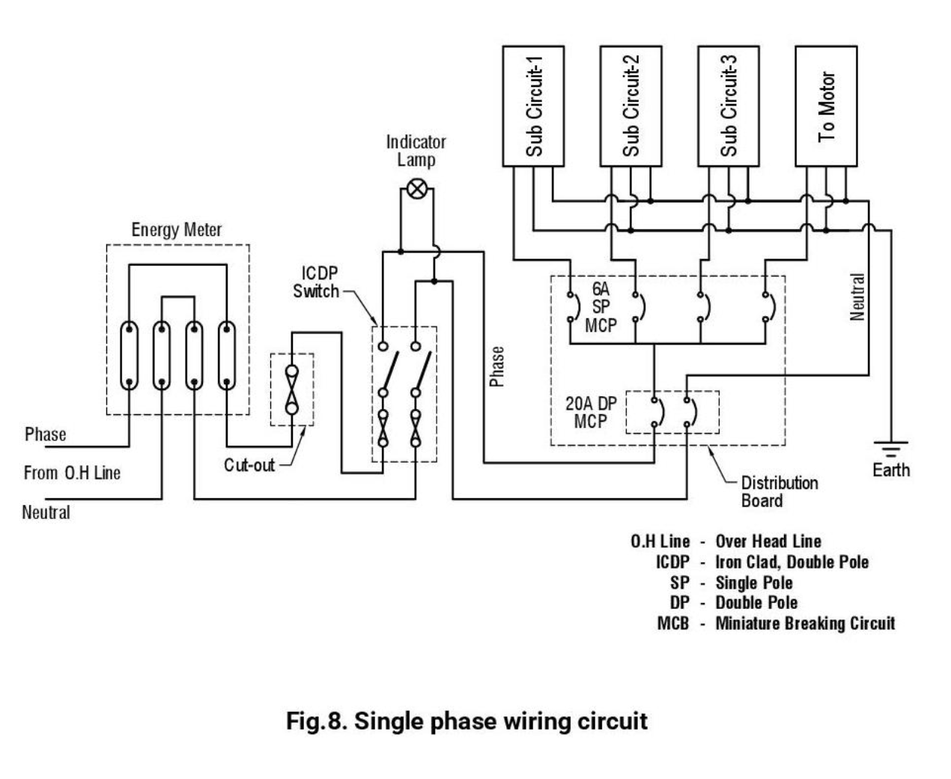

(ii). Draw the given electronics circuit diagram using CAD. - ECE, COMPUTER ENGINEERING AND ALLIED COURSES ONLY (1 × 25 = 25 marks)
- Half Wave Rectifier circuit
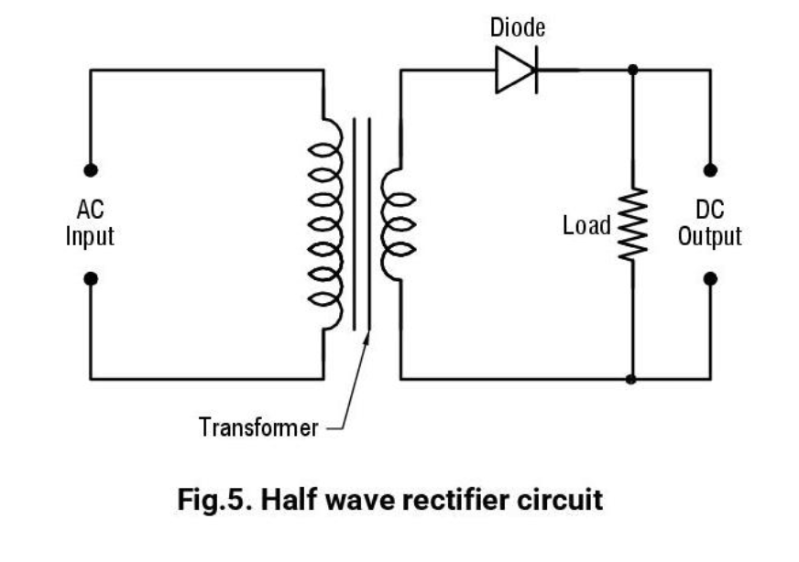

- Bridge Rectifier circuit
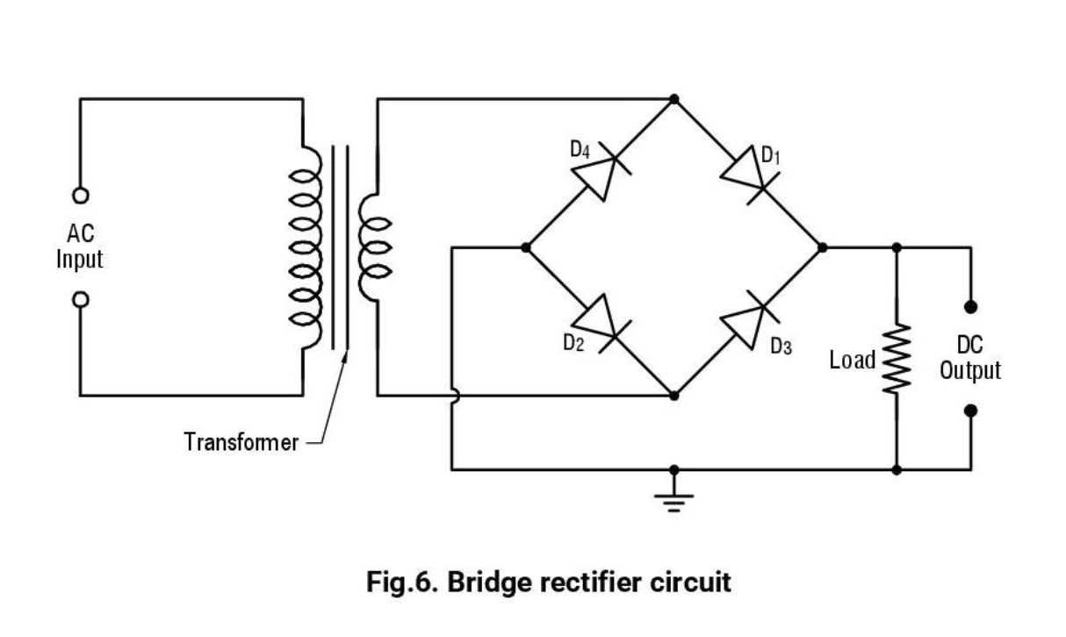
- Common Emitter Amplifier circuit
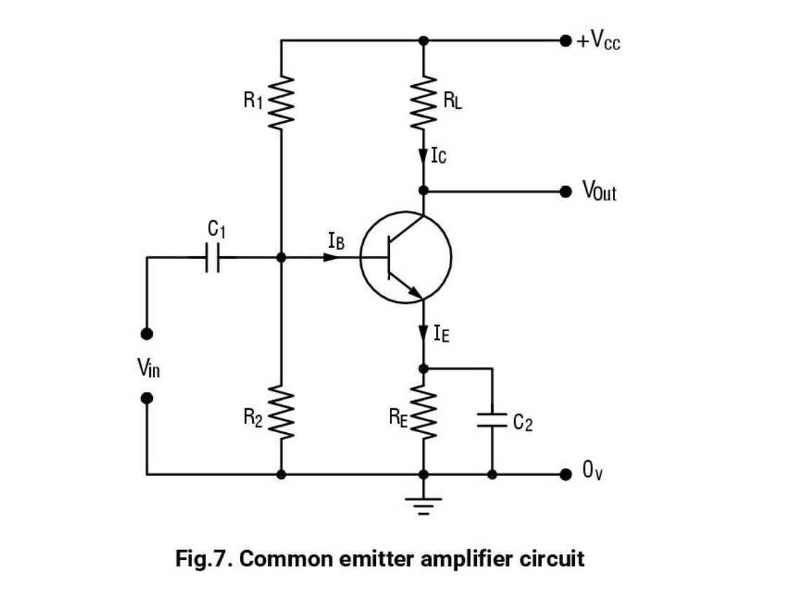

(d) Fire Alarm circuit

